Ear Syringing Self-Treatment Leaflet

Ear syringing at All Weymouth Surgeries
Ear syringing is a procedure that can disperse small particles like viruses into the air. With the covid pandemic this makes the procedure unsafe for staff and patients.
For many years now ear syringing has not been stipulated within our General Medical Service (GMS) NHS contract. Our GPs have a duty under the GMS contract to assess our patients, perform an appropriate examination and then decide either to treat our patients or refer to a specialist.
We can choose to provide this service. Unfortunately, due to significant changes to the way the surgery is running appointments, we have neither the resources nor funding to undertake this work.

What we can do is encourage self-care for patients.
There is evidence that oiling and self-irrigation can work well for a significant number of patients.
Reducing this demand on our time will allow our nurse team to focus on providing appointments for core clinical care such as review appointments for those for patients living with long term conditions such as diabetes and COPD.
In association with our advisors at Wessex LMC, we have taken available information forward to produce this leaflet and a process that our patients can go through, encouraging self-care, before accessing ear syringing.
Please note - We will never refuse appointments for those who have ear pain

Please do not attempt to self – treat if any of the following apply to you:

- Pain in the ear
- A history of ear drum perforation in the affected ear
- A recent history of an ear infection in the affected ear
- Symptoms of infection in the ear – usually pain or a smelly discharge
- If you have an offensive discharge or bleeding from the ear (this may mean you have an ear infection)
- If you only have one hearing ear which is the affected ear
- Previous ear surgery on the affected ear
- sudden deafness or buzzing
- foreign bodies in the ear
- dizziness

If you experience any of the above, you should seek advice from your GP or Nurse Practitioner.

Ear Syringing/Ear Care
If there is a build-up of wax in your ear(s) please read the following self-help guide as you may not need an appointment.

What is ear wax?
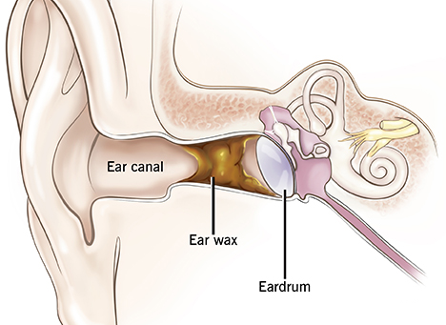
Ear wax is normal and is produced to form a protective coating over the skin in the ear canal.
Ears are normally self-cleaning – the movement of your jaw whilst eating and talking helps to move the wax along the canal where it will usually fall out naturally without you noticing.

Why is my ear blocked with wax?
The amount of ear wax produced varies from person to person; some people produce excessive amounts which can lead to a blockage in the ear canal.
You are more likely to develop a blockage of wax in the canal if you:
- use cotton ear buds to clean the ear as this pushes the wax deeper into the canal
- wear a hearing aid, ear plugs or use in-ear headphone - as these can all interfere with the natural process of wax expulsion
- have abnormally narrow ear canals
- have a particularly hairy ear canal
- are elderly – because the ear wax you produce is drier and harder
- have a dry skin problem such as eczema or psoriasis

Advice to help you manage and prevent ear wax blockage
Ear wax only becomes a problem if it causes deafness, discomfort or if your Health professional requires a clear view or your ear drum.
Olive Oil Drops –
The following needs to be done 2-3 times daily for 14 days.
- Lie on your side with the affected ear uppermost
- Pull the outer ear gently backwards and upwards to straighten the ear canal
- Put 2-3 drops of olive oil into the affected ear(s) and gently massage just in front of the ear
- Stay laying on your side to allow the wax to soak in for around 10 mins
- Afterwards, wipe away any excess oil but do not plug your ear with cotton wool as this simply absorbs the oil
Your hearing problem may initially worsen after first starting to use the olive oil drops; this is why we advise you to concentrate on treating one ear at a time if both ears are blocked with wax.
In most cases, after 14 days, the wax will have softened sufficiently to encourage the wax to come out without further intervention. However, if you feel your hearing is still impaired, please make an appointment with your GP for further advice and management.
Should I use cotton buds in my ears?
Never use cotton buds in your ears! This pushes the wax further into the ear making it worse. It can also cause ear infections and damage the ear drum.
Home Ear Syringing using a bulb syringe.
Ear syringing is only usually considered if the above recommendations have proved to be unsuccessful. Ear wax needs to be softened as above for 7-10 days before attempting to syringe). If your ears are regularly becoming blocked with wax, after clearing the blockage we will usually suggest you use olive oil drops as above around once per week to keep the wax soft and encourage the natural process of wax expulsion.
Bulb syringes
What is a bulb syringe and where can I get one?
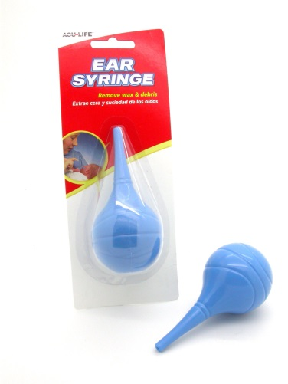
A bulb syringe is a small bulb shaped rubber object that will fill with water and allow the user to squirt the water gently into the ear to remove earwax. You can buy it from most pharmacies or online. It costs around £3 to £4.
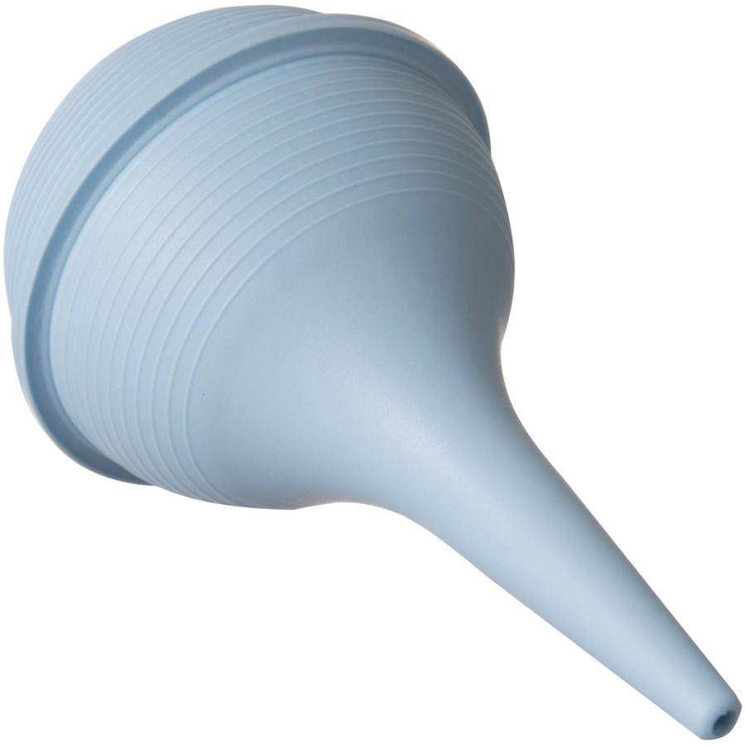

Alternatively, there are now over-the-counter kits available from pharmacies. These contain a wax softener which you use for 3-4 days and a small bulb syringe to enable you to remove the wax from your ear canals yourself. One such kit is called Otex Express Combi Pack (costs approx. £7.95).
We do not advise you use this type of preparation to soften wax before having your ears syringed as longer-term use can cause irritation and soreness to your ears.

When should a bulb syringe be used?
An ear bulb syringe should be used when one or both ears are blocked with wax. This is called wax impaction. The ears are usually self-cleaning as the skin cells of the ear drum and ear canal are constantly migrating outwards and most people do not need to interfere with their ears at all. Some people make more wax, or their ears do not clean the wax as effectively as others. In these cases, wax can build up inside the ear sometimes causing a blockage sensation and reduced hearing.
What are the benefits of the bulb syringe?
The main benefit of the bulb syringe is that you can use it yourself without needing to make an appointment with your practice nurse or GP. It is cheap to buy and can be re-used.
How effective is the bulb syringe?
A study on the use of the bulb syringe showed that half of patients who use it are successfully treated.
Is it safe and what are the risks of using a bulb syringe?
The use of the bulb syringe is commonly used in the USA or Europe. Two studies have shown the bulb syringe to be a safe treatment.
The risks of using the bulb syringe include failure to remove the wax and ear infection. These risks are low.
What if my ears are still blocked after using the bulb syringe?
The procedure can be repeated but if it fails make an appointment to have your ears examined. If self-syringing fails you may be referred for ear syringing or micro suction elsewhere.

How do I use the bulb syringe?
The bulb syringe will most likely come with instructions but below is some advice on how to use the bulb syringe (you may need a family member to help you, but it really is very simple):
- Firstly, use olive oil or sodium bicarbonate eardrops in the ear daily for 2-3 weeks. Apply a generous amount twice daily into the ear leaving he ear uppermost for 5-10 minutes after applying. If this does not clear the wax then the bulb syringe can be used.
- Put some clean warm (not hot) water in a bowl. Squirt the bulb syringe in the water a few times to fill it up with warm water.
- Hold your head to one side so the affected ear is facing upwards. You can do this in the shower or bath or lie on the bed with a towel underneath your head.
- If you experience any pain during or before this procedure stop immediately and see a practice nurse or GP for a review.
- Gently pull your ear in an upwards and outwards direction so that the water gets better access to the ear canal. Hold the nozzle inside the ear (not too deeply) and GENTLY squirt the water from the bulb syringe into the ear. You can gently squirt more bulb syringes into the ear if require. Leave the water in your ear for 1-3 minutes to soften the wax.
- Now tilt your head over so the water can fall out. Wiggle the outer part of the ear to help the water and wax come out. You can repeat the procedure if required.
- Repeat for the other ear if both ears are affected.
- If you get any pain or if the procedure is unsuccessful, see a practice nurse or GP.
Do I have to treat ear wax impaction (blocked ears from wax)?
No. If your ears being blocked with wax does not particularly trouble you then you do not have to treat it. You can use olive oil or sodium bicarbonate drops daily and this will help the ears clean themselves. You can get these drops over the counter in any pharmacy.
Can I go elsewhere for ear syringing or micro suction?
There are some local options for having ear wax removed privately.
- Specsavers, Weymouth
Prices for ear syringing are £55 regardless of having 1 or 2 ears treated. For an appointment or more information call 01305 761385.
https://www.specsavers.co.uk/stores/weymouth-hearing
- Imperial Hearing – Poundbury, Dorchester
Prices for microsection or ear syringing are £50 for one ear, £80 for both. Imperial Hearing offer micro suction but can provide an ear syringing service if preferred. For an appointment or more information call 01305 237250
https://www.imperialhearing.com/centres/dorchester/

Further reading
https://www.ncbi.nlm.nih.gov/pmc/articles/PMC3056857/
http://www.ncbi.nlm.nih.gov/pubmed/18186996

